**Approach**

* **Collecting Data**The first step was to collect data from reliable sources that will have to be MORTH(Ministry of Road Transport and Highways) or state police websites.  
    
  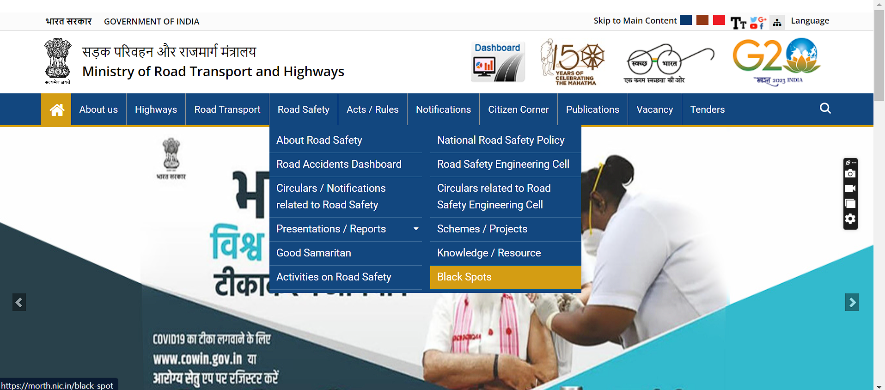

Clicking on the blackspots option gives us statewise data of the blackspots  
  
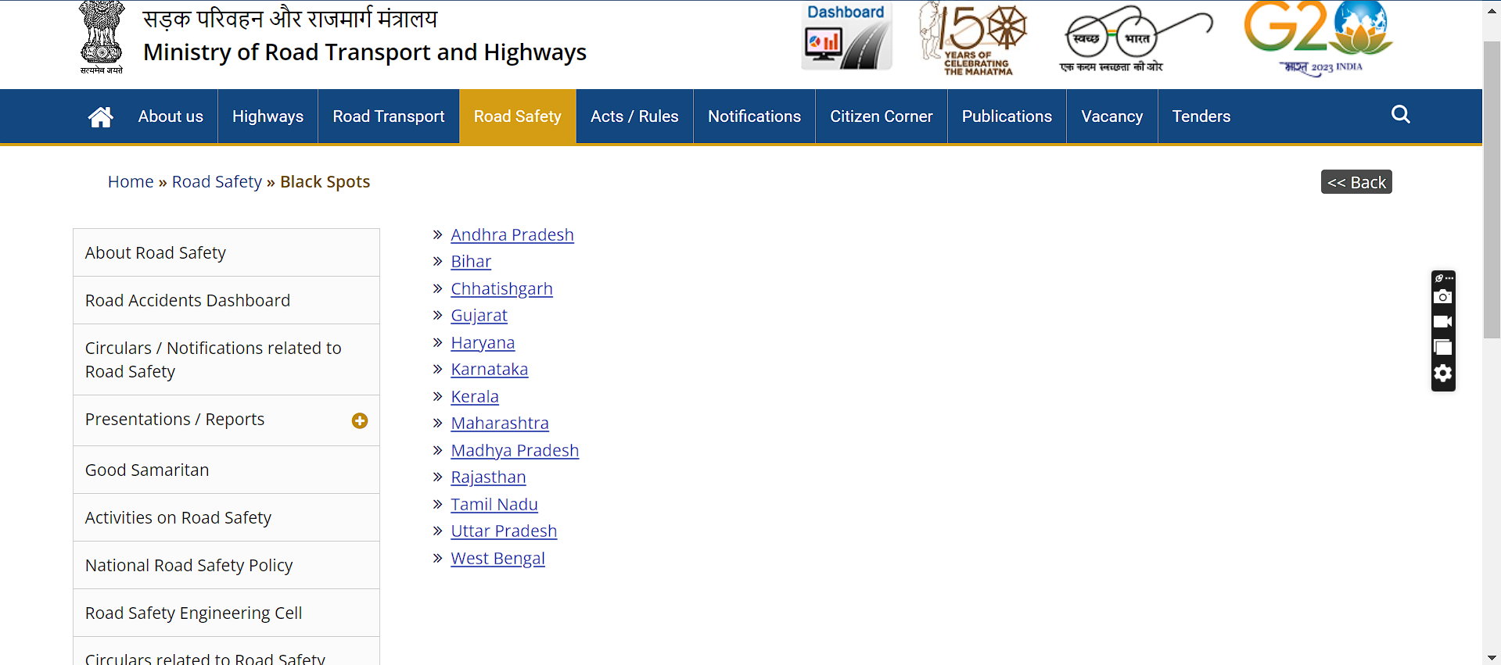

Now to access the data just click on the state name and you can see the data present for different states of India

E.g.: - Data of Uttar Pradesh

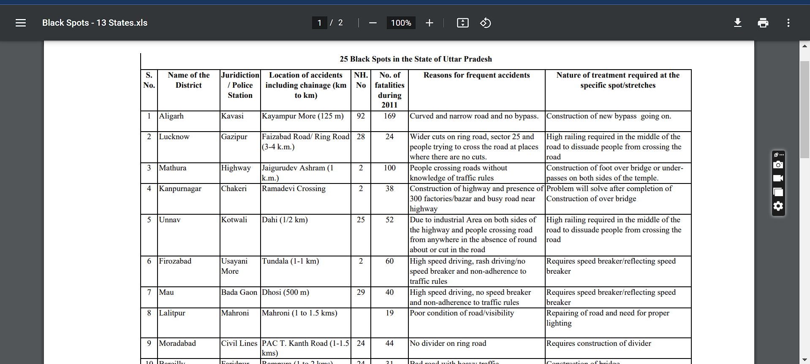

* **Obtaining the Google Maps API Key**To get the API Key we need to visit the google cloud services and select the necessary services like geolocation and make a project to avail the key for the API  
    
  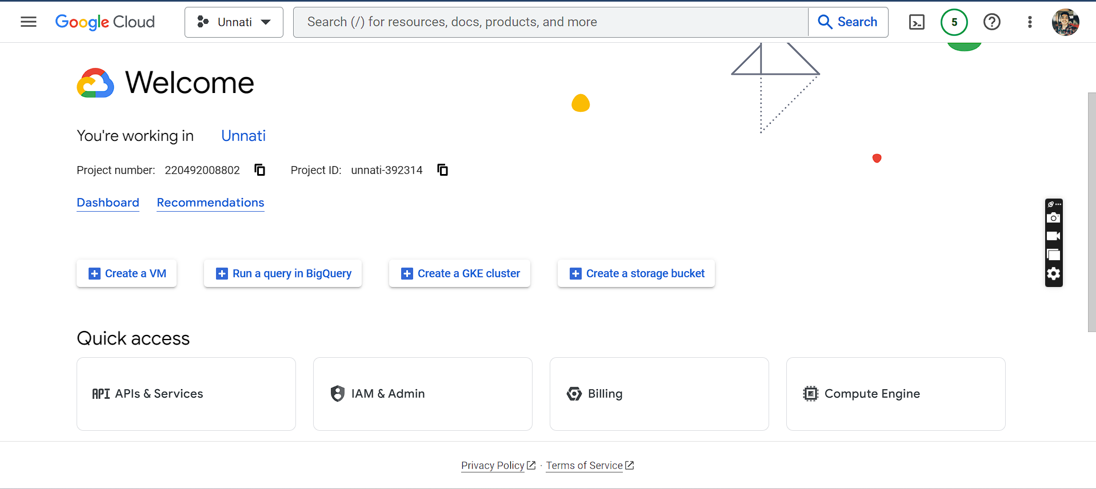
* **Download QGis**QGis is the tool which I used here for mapping the blackspots data

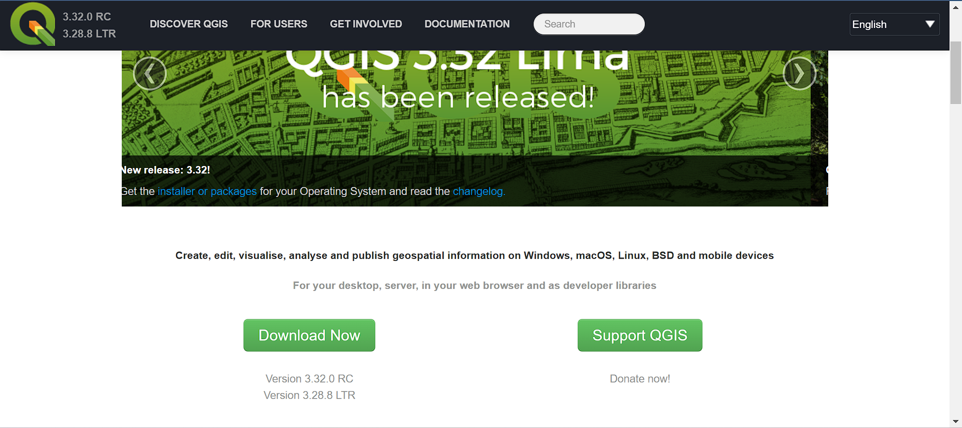

* **Code**

Now we will code for extracting the coordinates of the blackspots  
  
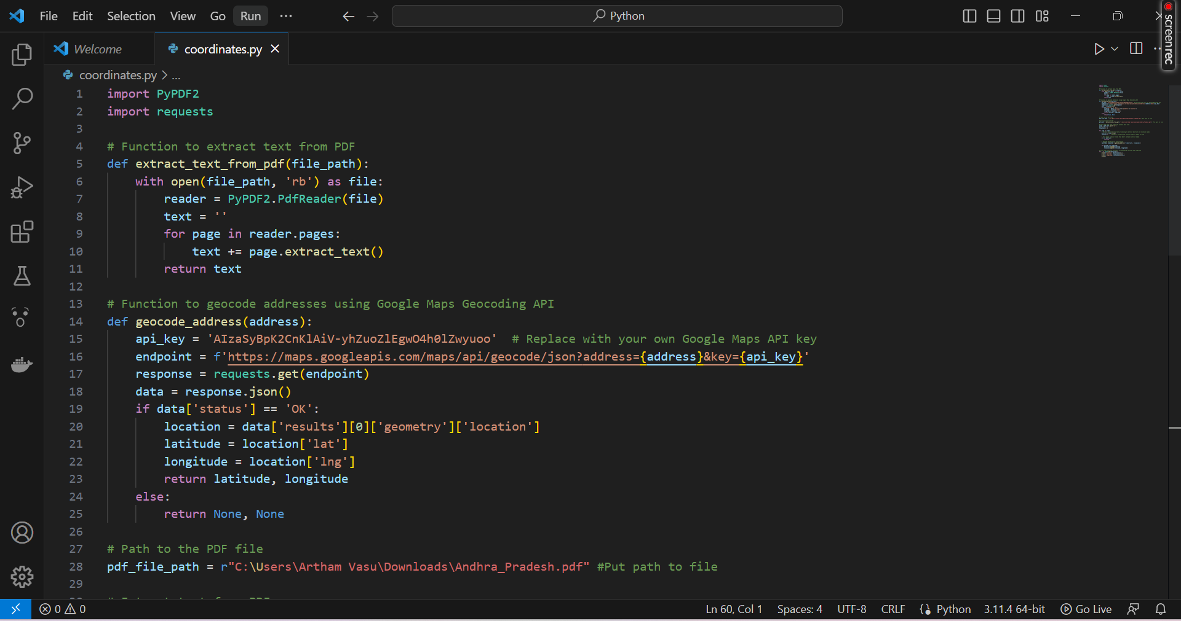

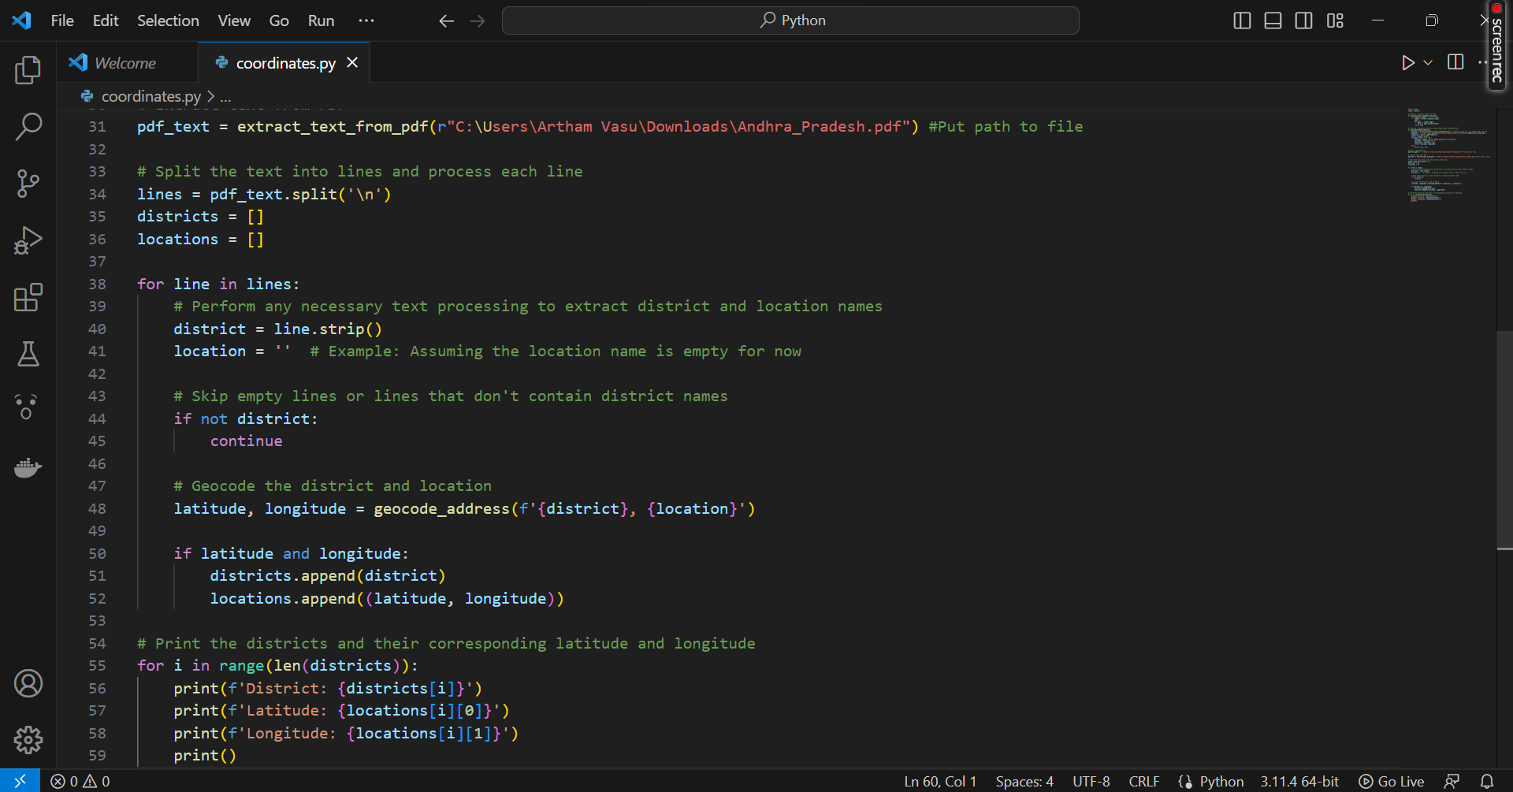

After executing the code Output is obtained that is in the following format containing the name of the district and its latitude and longitude  
  
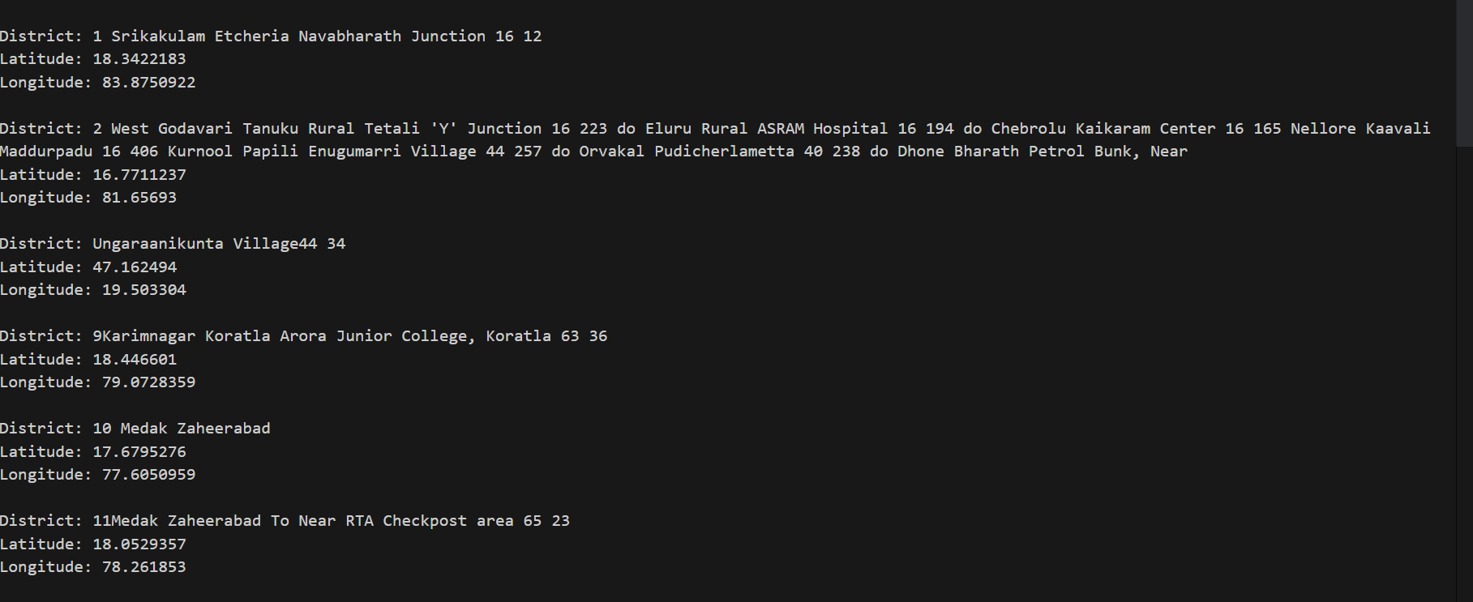

* **Now format the data and Import it into Excel**

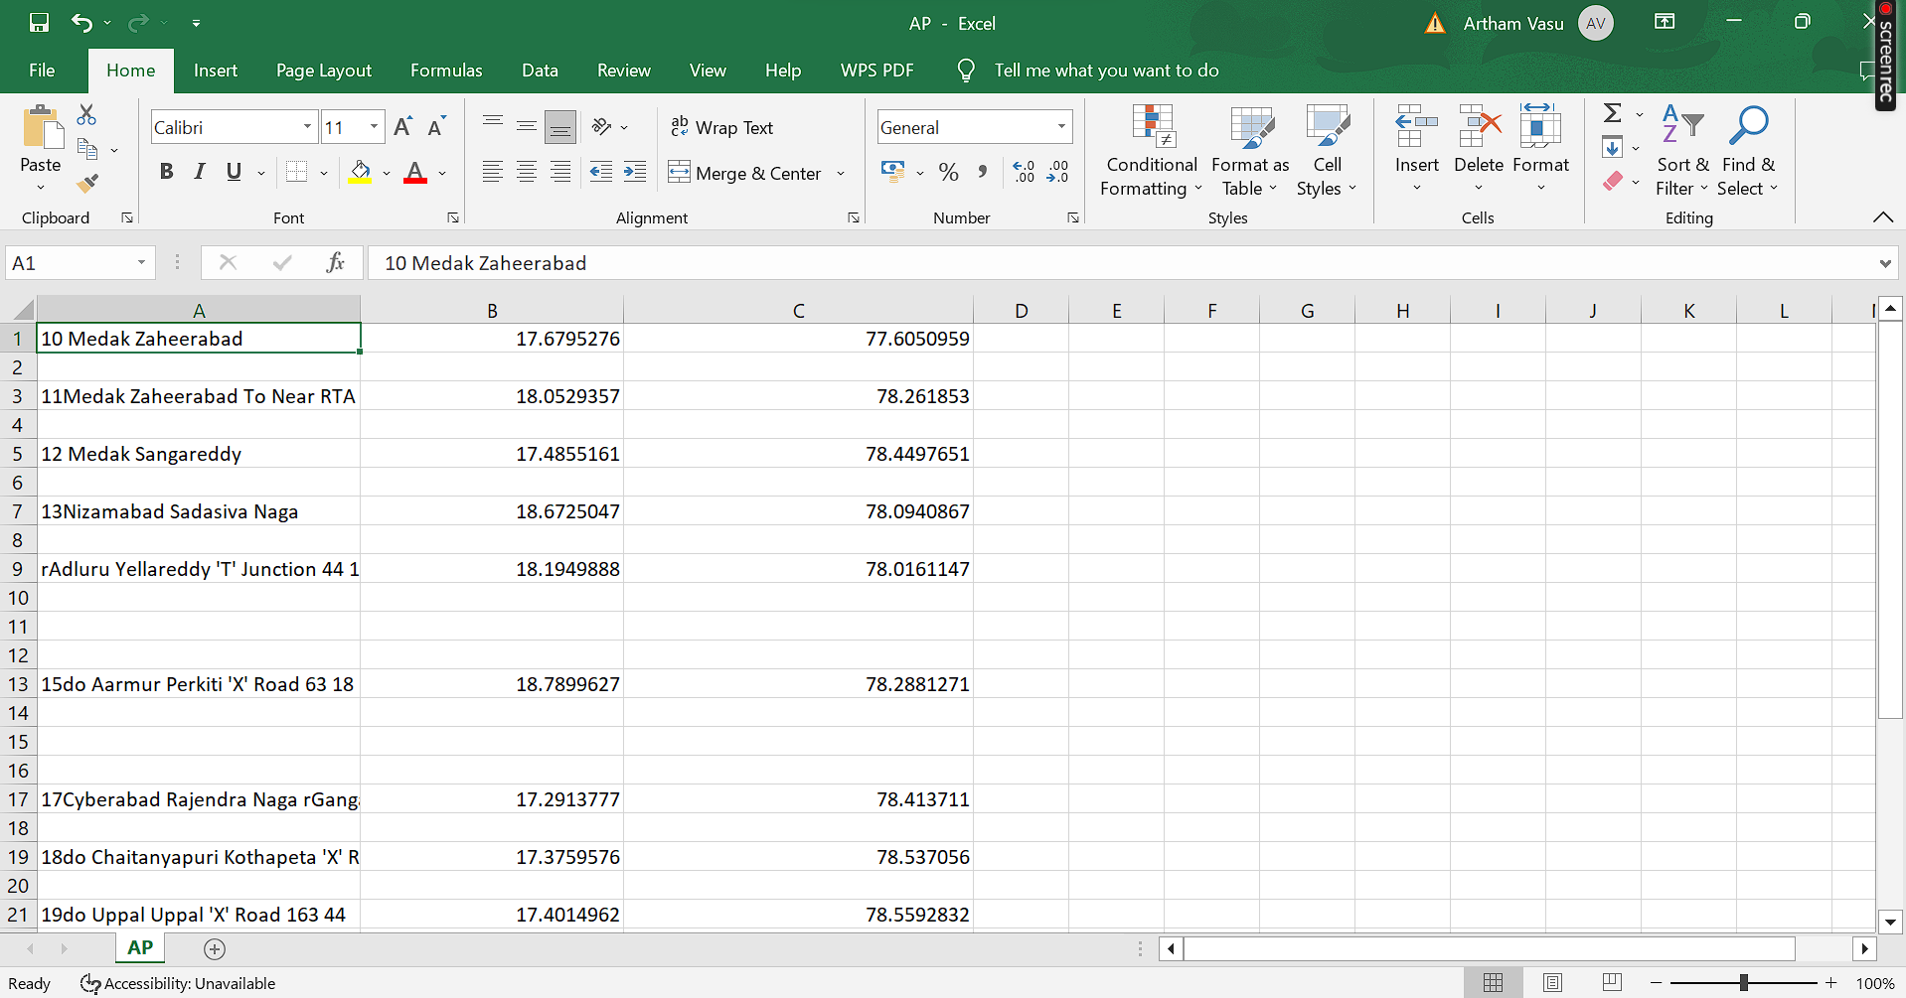

Now we will save this file as a CSV(Comma Delimited) file

* **Import the saved CSV FILE in QGis**First Click on Layers->Add Layer->Add Delimited Text File  
  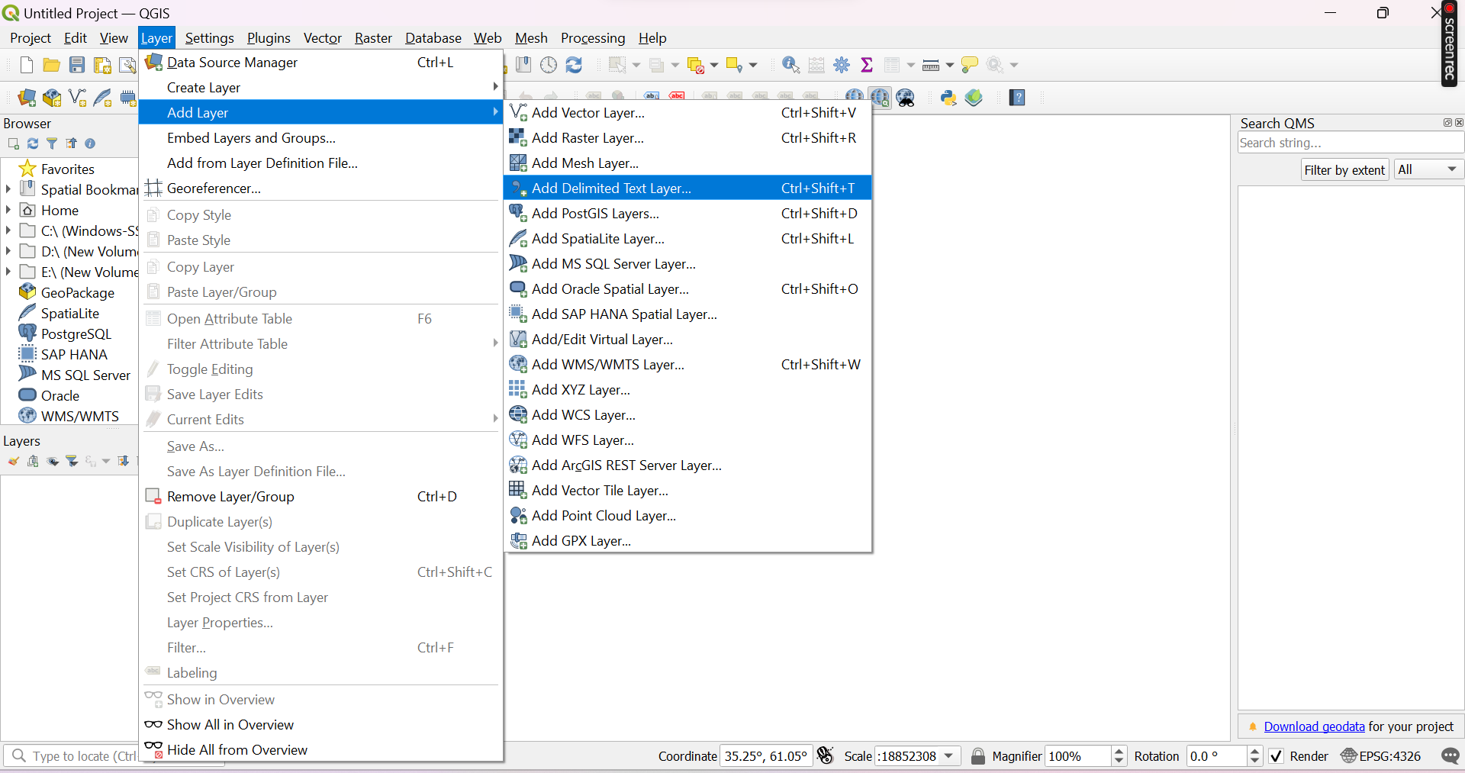

Then put information of the saved csv file  
  
Make sure that the X field has longitude and Y field has Latitude and then click on Add button

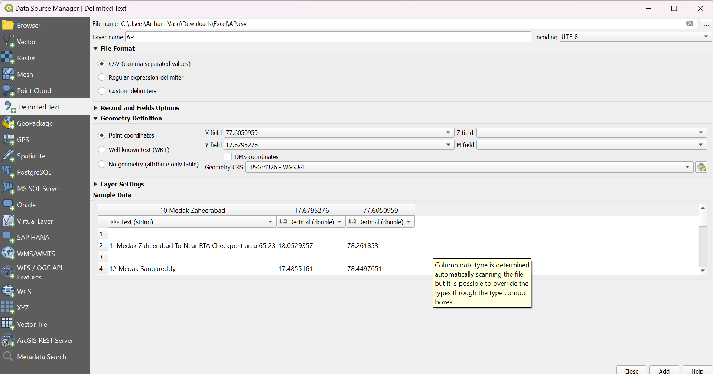

Then you will have to add a map layer  
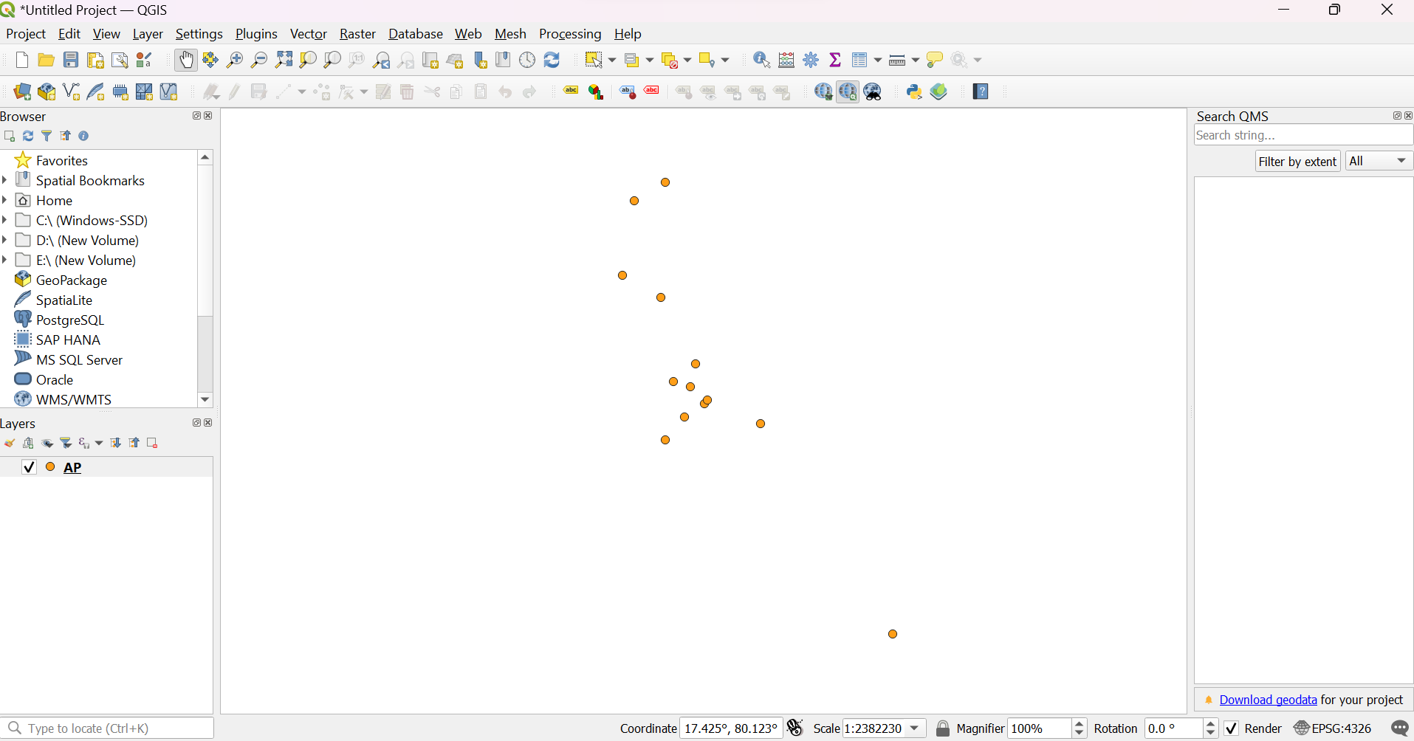

Click on web and then add osm standard map as follows  
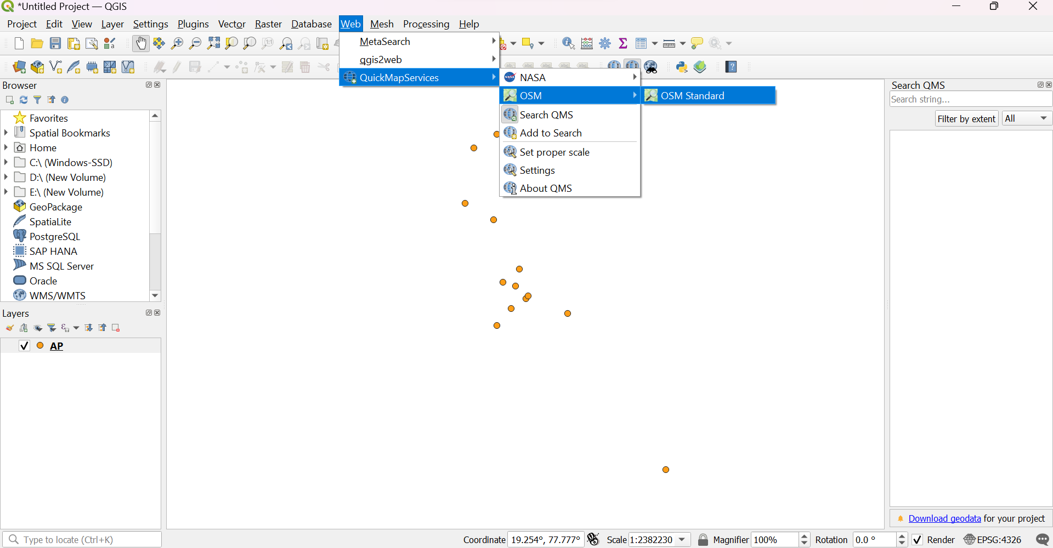

Then you get to see the points plotted on the map  
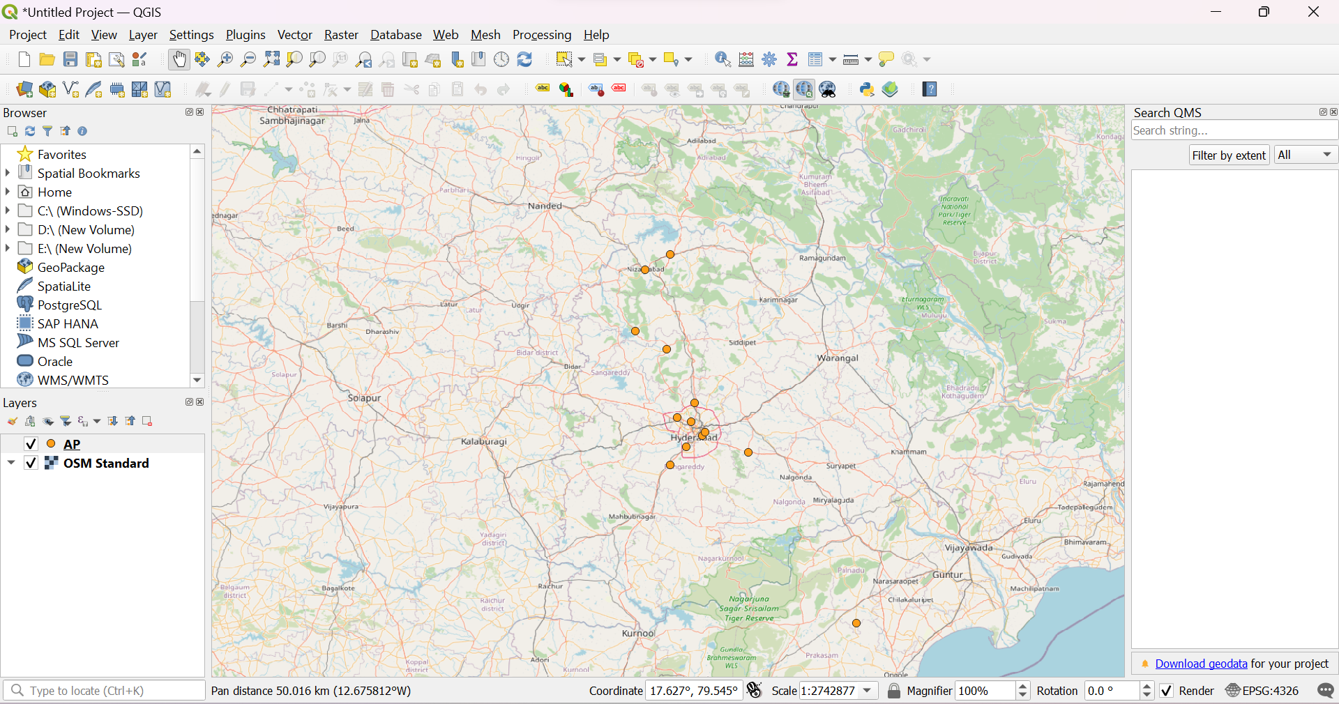

Now add data of every state we ll have to complete map  
  
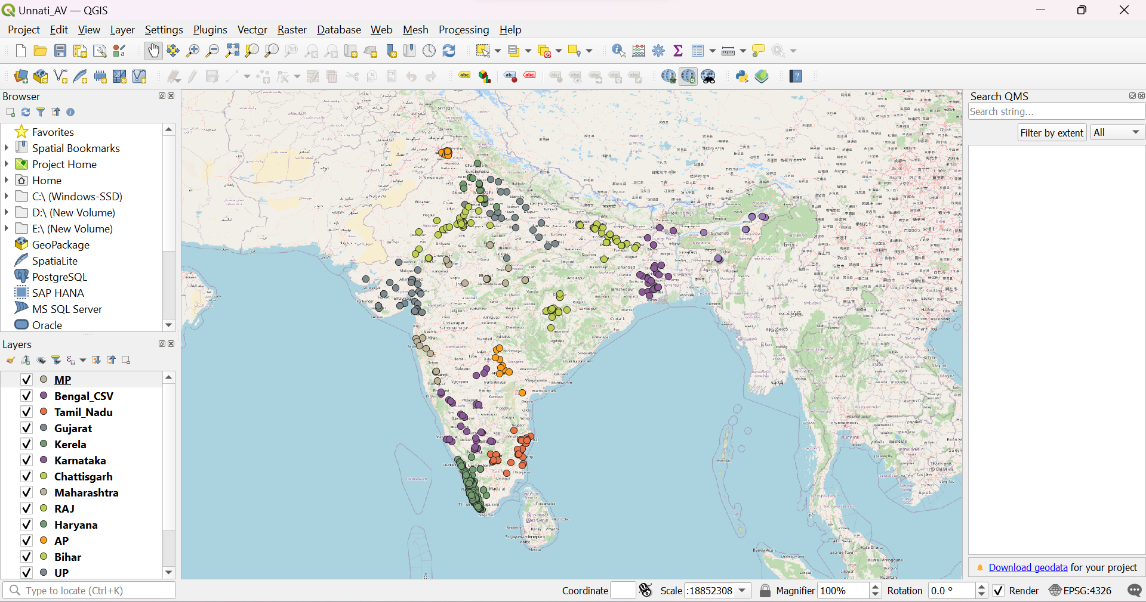  
Here we have all the data plotted on the Map.